Date:
Wellington-Dufferin-Guelph (WDG) Public Health is working to manage COVID-19 cases and contacts. You have been identified as a close contact of someone diagnosed with COVID-19.
As a high-risk contact, you are required to self-isolate and monitor yourself for any COVID-19 symptoms for 10 days after your last contact with the person who tested positive for COVID-19. Please isolate until end of day on [DATE] . The exception to this is if you are fully immunized or have had COVID-19 in the past 90 days. Please refer to the flowchart below, for next steps.
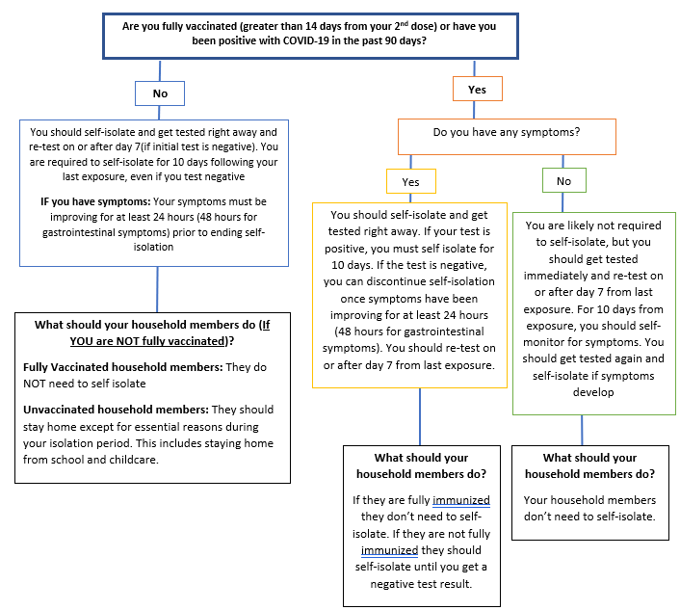

Instructions for your Household members
If you are required to self-isolate as a high risk contact, children living at the same address, will have to stay home from school or child care for 10 days as well if they are not fully vaccinated, or previously positive
- When all children living at the same address (for example siblings or cousins), that are not fully vaccinated or previously positive, stay home from school or child care, it reduces the risk of further spread and outbreaks in school and child care settings.
- Households have a high level of transmission, and this is the safest action we can take to protect the community.
- The people you live with should also stay home during your 10-day self-isolation period, except for essential reasons
- Household members should work from home if possible.
- Adults in the home should monitor everyone in the household for COVID-19 symptoms every day.

Getting Tested
You do not need an Ontario Health Card to get tested for COVID-19 at an assessment centre. Please visit our website for a list of assessment centres in the WDG Region (https://www.wdgpublichealth.ca/your-health/covid-19-information-public/testing-and-assessment-centres-wdg). Please note, you will need to book an appointment to get tested.
If you have a green health card, the test results will be available online. Visit the Ontario COVID-19 website to access your results (https://covid19results.ehealthontario.ca:4443/agree)
When going to an assessment centre, drive yourself there if possible. If you must be a passenger in a vehicle, wear a face covering and sit in the back seat with the windows down. Do not use public transportation or ride share services.
- If your test results are negative (and you are not fully vaccinated), you must continue to complete the 10-day isolation period from the date of last contact with positive case (e.g., do not return to school/work).
- If your test results are negative (and you are fully vaccinated), you do not need to isolate unless you have symptoms. Refer to above flowchart for more information.
- If your test result is positive, you should continue to self-isolate and WDG Public Health will contact you with further instructions.
Please visit our website for more information on how to self-isolate and how to self-monitor.
COVID-19 symptoms:
- Fever
- New or worsening cough
- Difficulty breathing
- Sore throat
- Loss of taste or smell
- Headaches
- Runny nose or nasal congestion
- Muscle aches
- Tiredness
- Vomiting, diarrhea, abdominal pain
- Pink eye
- Decrease or lack of appetite

If you are instructed to self-isolate here are some tips to reduce the risk of potential COVID-19 exposure to other people:

Stay home
- Do not return to work
- Do not go outside, unless on to a private balcony or private enclosed yard
where you can avoid contact with others
- Do not use public transportation such as buses, taxis or ride-shares
- Shop online or have a family member or friend pick up supplies for you

Avoid contact with others
- Only essential visitors, such as care providers
- Avoid close contact with anyone who has higher risk for serious illness
  - Examples: medical conditions; compromised immune system; or older adults
- Limit your interactions with household members as much as possible
  - Isolate in a separate room and use a separate washroom if you can
  - Disinfect shared common spaces after each use, such as the kitchen
- Make sure that shared rooms have good airflow (open windows for periods of time)

Keep a Distance
- Keep a distance of at least 2 metres (6 feet) and wear a face covering when in a room with other people, including your household members
- If you cannot wear a face covering, the other people around you should wear a face covering when in the same room with you

Wash your Hands
- Wash your hands frequently with soap and water
- Dry your hands with a paper towel to put in the garbage after use or dry your hands
with your own cloth towel that no one else in your household shares
- Use an alcohol-based hand sanitizer if soap and water are not available

Cover your Coughs and Sneezes
- Cover your mouth and nose with a tissue when you cough and sneeze
- Cough or sneeze into your upper sleeve or elbow, not your hand
- Line your wastebaskets with a plastic bag to make waste disposal easier and safer
- Throw used tissues in those lined wastebaskets and wash your hands afterwards
- Wash your hands after emptying wastebaskets and lining with new plastic bag

Wear a Face Covering Over Your Nose and Mouth
- Wear a face covering if you must leave your house to see a health care provider
- Wear a face covering when you cannot maintain physical distance of 2 metres (6 feet)

Government Benefit Information
The Government of Canada has introduced three new financial benefits: the Canada Recovery Benefit, the Canada Recovery Sickness Benefit, and the Canada Recovery Caregiving Benefit. If you require financial support during your isolation period refer to this website for more information.

When to seek medical attention
If you develop symptoms or your symptoms are worsening, and you are concerned, contact Telehealth Ontario at 1-866-797-0000 or your healthcare provider.
If you need urgent medical attention, contact 911. Please inform healthcare workers or 911 that you have been in close contact with a positive case and wear a face covering, if possible, to limit exposure to medical professionals attending to you.
If you have any general questions or concerns, please consult with WDG Public Health website: https://www.wdgpublichealth.ca/
If you develop symptoms, you can reach WDG Public Health at: 1-800-265-7293 ext. 4000.

Vaccination

Vaccines are available for those born in 2009 and older. WDGPH is offering walk-in COVID-19 vaccine clinics at various sites in the Wellington, Dufferin and Guelph areas. You can not attend a vaccine clinic if you are currently self-isolating.

If you would like to book an appointment:
To book an appointment call 1-800-265-7293 ext. 4000. This extension will ask you to leave a voicemail with your name, number, and reason for calling. We will then return your call as soon as possible.

If you would like to walk-in to one of the WDGPH COVID-19 vaccine clinics:
Please visit our website to find a list of clinic locations.

If getting to a vaccine clinic is challenging for you:
If you have concerns about getting to one of our clinic locations please call us and we will do our best to accommodate your situation.

